Major Web Project

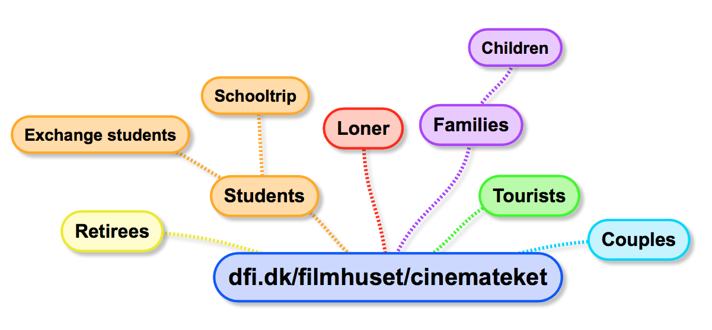 Mandatory Assignment: Design Implementation   
 [http://www.dfi.dk/Filmhuset/Cinemateket/Billetter-og-program/Serie.aspx?serieID=11464/](http://www.dfi.dk/filmhuset/Cinemateket/danish.aspx)

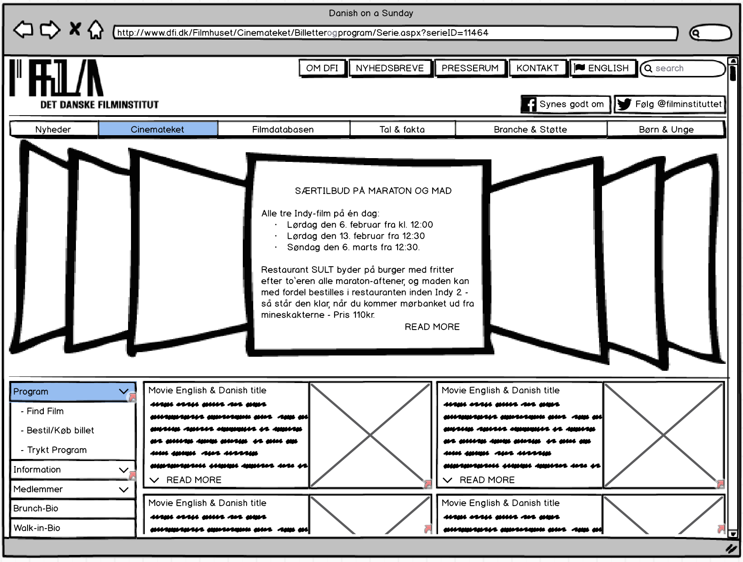

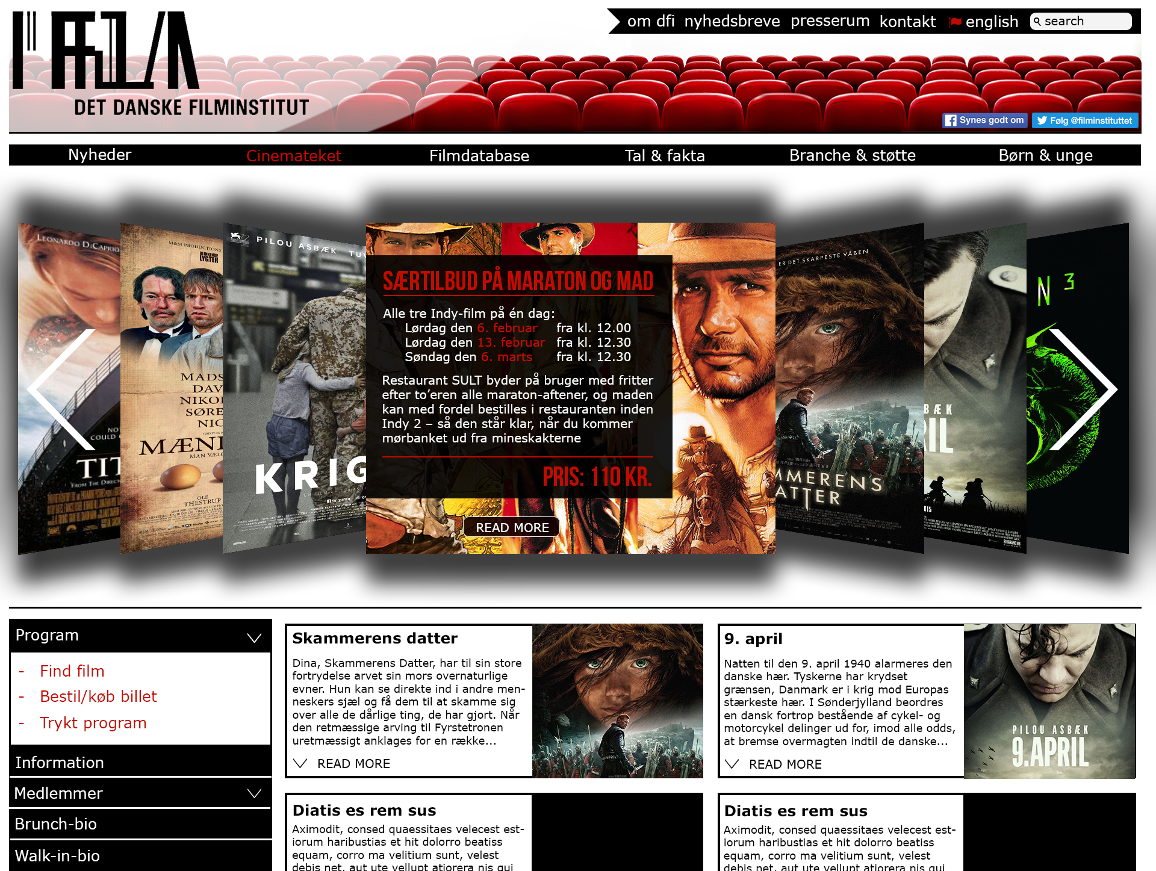

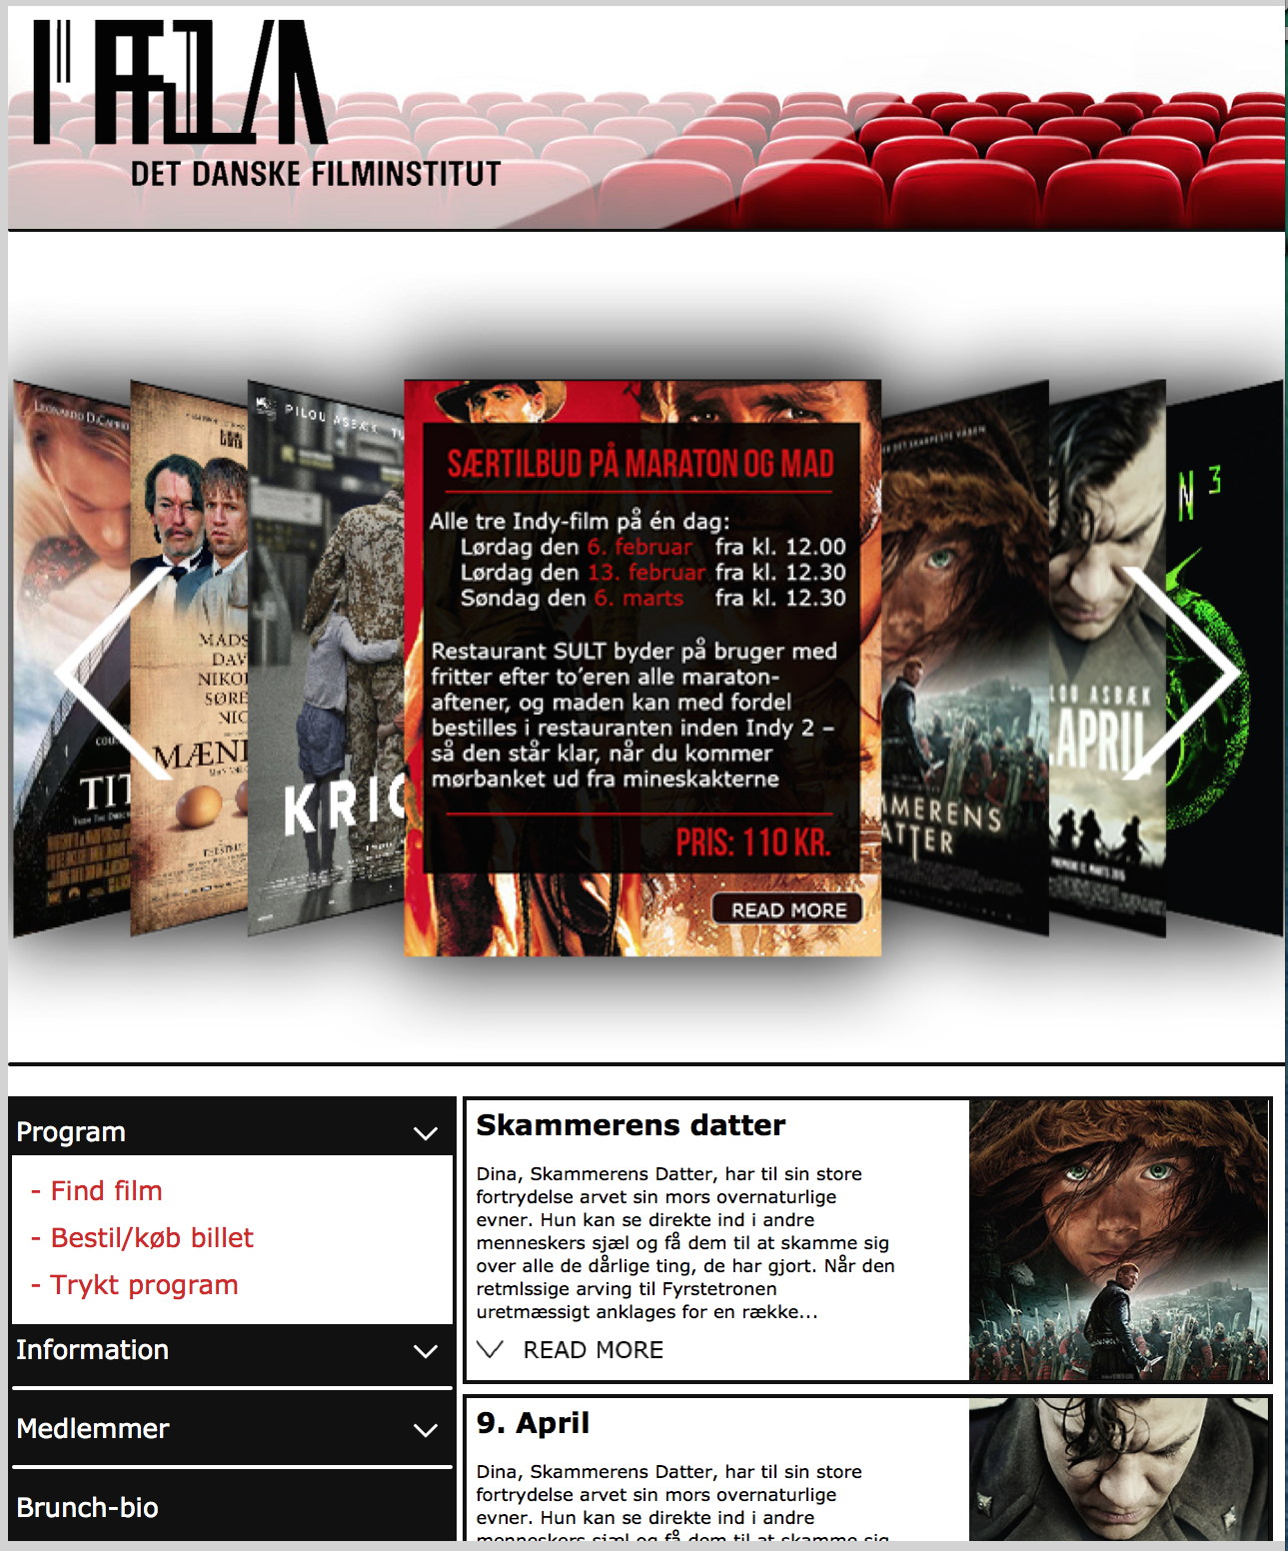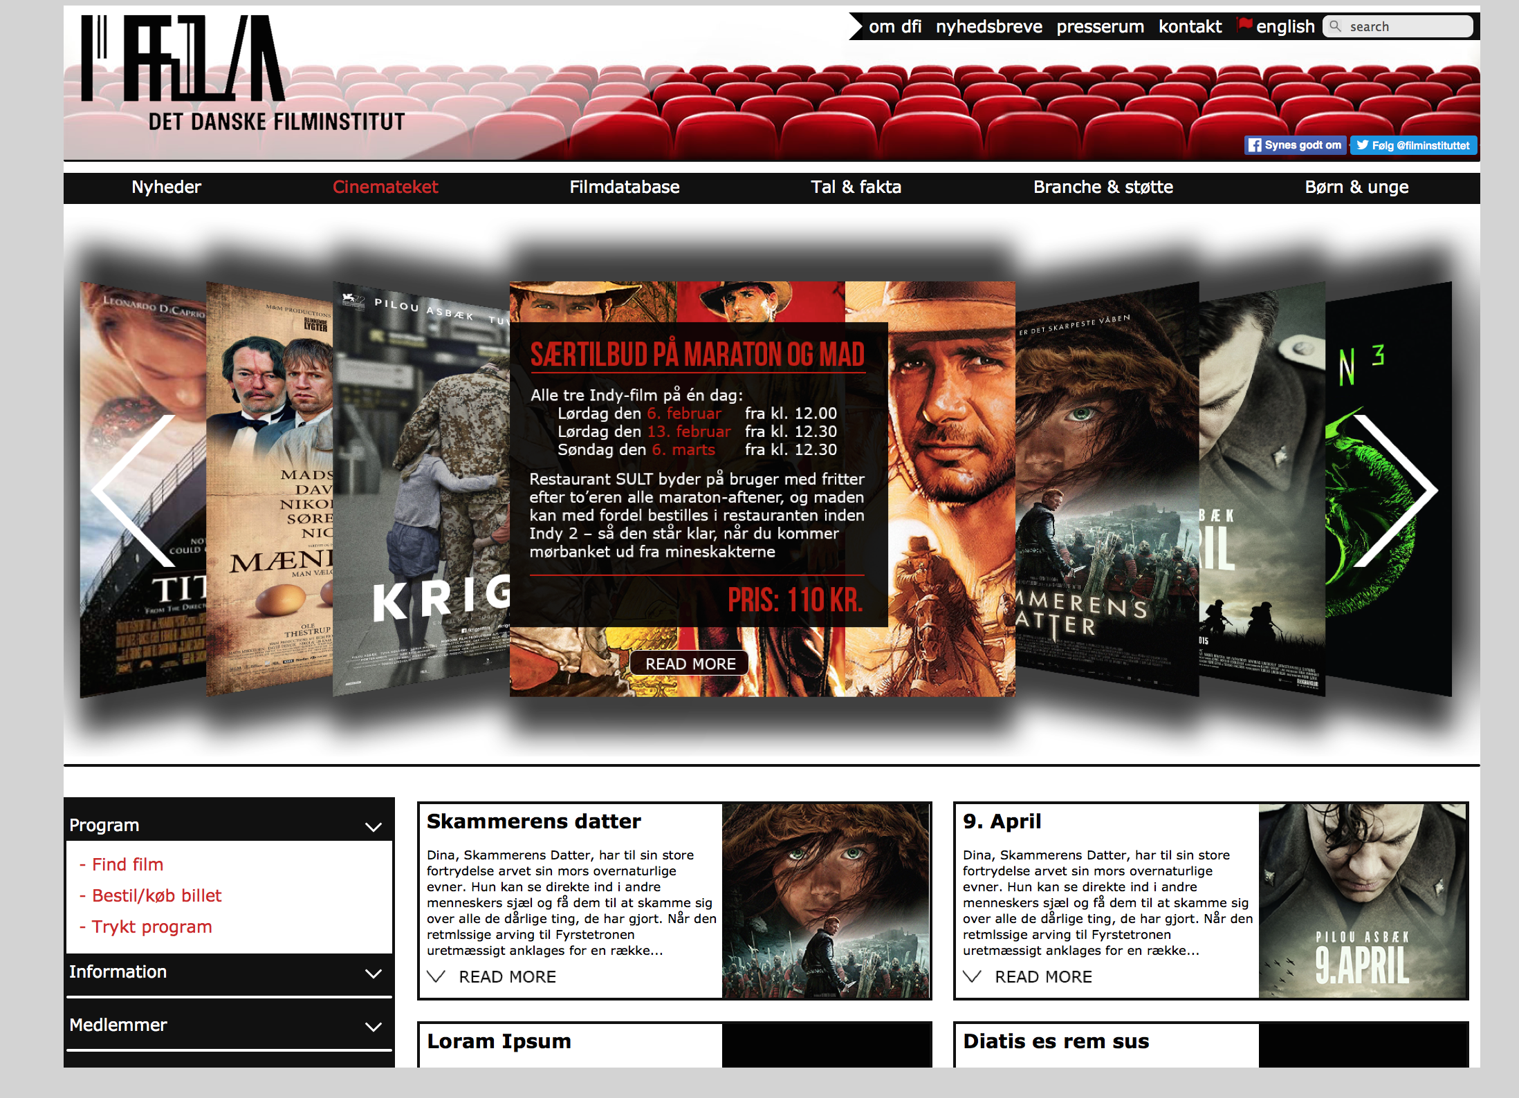

Desktop Version Mobile Version

By: Asger Balle Pedersen

# Preface

Statement from the Assignment:

“Your response design needs to target smartphones and desktop devices. You do not need to implement a responsive design that targets tables but the principle is the same… ”

As a consequence of targeting the mobile version for tablets in the first assignment, I have developed a website with a responsive design between a desktop- and a table mobile version. In principle, it is the same as targeting a smartphone version and it gives an opportunity to compare the visual designs between assignment 1 and assignment 2.

The Implementation HTML and CSS of the three designs from assignment 2 can be viewed in the zip folder along with this document.

# Produce responsive static HTML and CSS mock-ups

Overview and Pattern of HTML and CSS documents in the static version:

|  |  |  |  |
| --- | --- | --- | --- |
| Html\Version | Mobile Version  (0px - 648px) | Desktop Version (649px - 1024px) | Desktop Version  (1024px - infinite) |
| Index.html | style_max648px.css | style.css | style_min1024px.css |
| MoviePage.html | style_max648px.css | style.css | style_min1024px.css |
| NavPage.html | style_max648px.css | style.css | style_min1024px.css |

## Quality of code:

The page has been cut to fit the Photoshop mock-ups by adding *overflow: hidden;* and a specific *height: “value”,* this will of course be changed in an actual implementation on the Internet along with the missing pages reference.

Documentation of code is done when special structures, patterns or operators are used:

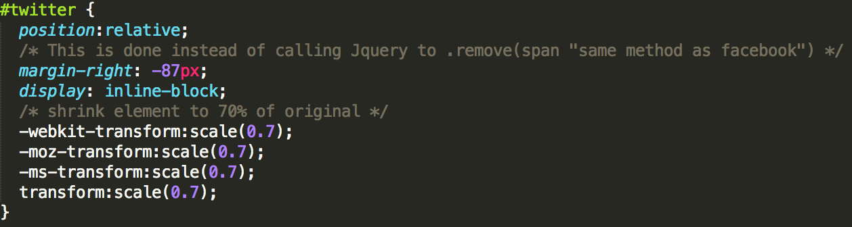

## 

## The major differences between my HTML and Photoshop version:

- The type of font used Assignment 1: “Myriad” Assignment 2: “Verdana”.

- Twitter count box (API configuration)

- Facebook count box[1]

The API code generation and removal of the count box

- The CSS menu[2] The interactive CCS “vertical left menu” with dropdown/expand properties. The link provides similar code, where colour, image and horizontal/vertical alignment are the main differences.

- The Coverflow[3] plugin can be easily included with Coverflowjs, current version 3.0.2. The Coverflow will need some alteration due to the missing white arrow both left and right. The arrows will adherence the function from the already existing “click action” on both sites of the displayed center-picture.

- The Navigation Map plugin[4] can easily be generated in the following site and implemented directly into my NavPage. But the navigation-map-code needs to be altered to contain more pointers with different images and coordinates, colours, zoom distance etc.

# Wordpress:

I have used the underscores.me to provide the general layout theme. The theme is meant for hacking, which will be my approach, instead of a child-parent relation. It is based on an open source on github[5]. I also used the Deskwolf helper application to provide some auto-generation of code and structures[6]. The collection of pictures for my website has been uploaded via imgur.com for an easy http reference platform[7].

The primary layout in Wordpress has not been fully implemented. Instead the focus has been on trying functions and loops combined with different approaches on hacking and child-parent relation between layouts. A post on the template “Danish on a Sunday” (CMS Wordpress) has been configured to accept a “movie” post as a headline, text and picture and therefore more or less replaced the moviePage.html form the static version. In the WordPress version, also a google map is added, along with a simple and not fully customized slider (coverflow).

The Wordpress part is just to demonstrate that I can construct elements, functions, pages, post, slider and different menus and, with more time at hand, can develop a fully functional CMS system for my website.

# Server / website walk-through:

Access my website by this link: [http://asbp.frwaw.itu.dk/](http://asbp.frwaw.itu.dk/index.html)

From this index-page you can access the two separate parts of the assignment:

Assignment 2 Part A: Show the static HTML and CSS version

Assignment 2 Part B: Show the Wordpress version

Both parts of assignment have a navigation-walk-through-helper to avoid the null pointer links on each version.

1. <https://developers.facebook.com/docs/plugins/like-button>
2. <https://css-tricks.com/targetting-menu-elements-submenus-navigation-bar/>
3. <http://coverflowjs.github.io/coverflow/>
4. <http://maps-generator.com/>
5. <https://github.com/automattic/_s>
6. <http://danishonasunday.deskwolf.net/home/>
7. <http://imgur.com/a/jHLG3>